**Week 12**

Q1. Identify the requirements for a library information system.

A **Library Information System (LIS)** is designed to manage and organize a library's resources, services, and operations efficiently. To build an effective LIS, the following requirements must be considered:

**1. User Requirements**

* **User Profiles**: The system should accommodate various types of users (e.g., library members, staff, administrators) and provide access levels based on roles.
  + **Library Members**: Search for books, borrow items, renew loans, reserve books, view borrowing history, and manage personal profiles.
  + **Staff**: Check in and check out items, catalog new items, manage user accounts, and generate reports.
  + **Administrators**: System-wide settings, configuration, and full access to all features.

**2. Cataloging and Metadata Management**

* **Item Information**: The system should store detailed information about each item, including title, author, publisher, ISBN, classification (Dewey Decimal, Library of Congress), and item status (available, borrowed, reserved).
* **Classification and Organization**: Categorization of books, journals, media, and other resources in the library.
* **Search Capabilities**: Advanced search functionality, such as keyword, title, author, subject, and ISBN search.

**3. Inventory Management**

* **Barcode/RFID Integration**: To track and identify library items (books, journals, CDs, etc.) easily.
* **Item Availability**: Real-time tracking of whether an item is available, reserved, or on loan.
* **Stock Management**: Maintain an up-to-date record of all library items, track lost, damaged, or missing items, and automate reordering of popular or essential materials.
* **Reservations and Holds**: Support for reserving books or other resources, including notifications when an item is available.

**4. Circulation Management**

* **Borrowing and Returning**: Enable users to borrow and return materials, track due dates, calculate overdue fines, and provide due date reminders.
* **Renewals**: Allow users to renew items unless reserved by others.
* **Loan History**: Track and display users' borrowing history.
* **Fines and Fees**: Automatically calculate fines for overdue materials and allow for payments or fee management.

**5. Online Public Access Catalog (OPAC)**

* **User-Friendly Interface**: A web-based or integrated search platform for users to browse the catalog.
* **Account Access**: Enable users to log in, check account details, renew items, and manage reservations.
* **Availability Info**: Display real-time information about the availability of items in the library.

**6. Acquisition Management**

* **Purchase and Order Tracking**: Track new acquisitions and their approval processes.
* **Vendor Management**: Manage relationships with suppliers and publishers, including procurement, pricing, and invoicing.
* **Budgeting and Financials**: Support for budgeting and tracking library expenditures.

**7. Reporting and Analytics**

* **Reports Generation**: Ability to generate reports such as circulation statistics, user activity, overdue items, inventory status, and financial reports.
* **Analytics**: Track usage trends, popular books, borrowing patterns, and user engagement.

**8. Security and Access Control**

* **Authentication and Authorization**: Implement security protocols for logging in users, assigning roles, and managing permissions.
* **Data Protection**: Secure handling of sensitive data (e.g., user personal information, borrowing history) in compliance with privacy regulations.
* **Audit Trail**: Keep track of all system actions, including check-ins, check-outs, and changes made to user accounts.

**9. Integration with Other Systems**

* **Integrated Library Networks (ILN)**: Integrate with other libraries for inter-library loans, resource sharing, and catalog syncing.
* **E-Resource Management**: Integrate access to electronic resources, including e-books, journals, databases, and online subscriptions.
* **External Payment Systems**: Integration with online payment systems for fines or membership renewals.
* **Integration with Learning Management Systems (LMS)**: Connect to educational platforms for academic libraries.

**10. Mobile and Remote Access**

* **Mobile App**: A mobile-friendly interface or dedicated app for users to search the catalog, reserve items, and manage their accounts on the go.
* **Remote Access to E-resources**: Allow users to access digital materials, including databases and e-books, remotely.

**11. System Maintenance and Backup**

* **Data Backup**: Regular system backups to prevent data loss.
* **Software Updates**: A process for updating the system to add features, fix bugs, and ensure compatibility with new technologies.
* **Technical Support**: A help desk or technical support system to assist users with any issues.

**12. User Training and Support**

* **Training Resources**: Provide tutorials or help documentation for users and staff to understand how to use the system efficiently.
* **Helpdesk**: A support system for users to report issues and get assistance.

**13. Compliance and Standards**

* **Standards Compliance**: The system should conform to relevant library standards, such as **MARC** (Machine-Readable Cataloging), **Dewey Decimal Classification**, and other metadata standards for cataloging.
* **Privacy and Accessibility Compliance**: Ensure compliance with data protection laws (e.g., GDPR) and accessibility standards (e.g., WCAG) for disabled users.

**14. Customization and Scalability**

* **Customization**: Ability to customize the system according to the specific needs of the library, such as adjusting workflows, categories, or adding special modules.
* **Scalability**: The system should scale easily to accommodate growth in the library’s collection, users, or services without significant overhauls.

**15. Support for Special Collections**

* **Archival Materials**: Features for managing rare books, special collections, manuscripts, or historical archives that may require more intricate handling.
* **Multimedia**: Management of multimedia materials, such as DVDs, CDs, or audiobooks, with different borrowing policies.

Q2. Create a use-case diagram for the library information system.

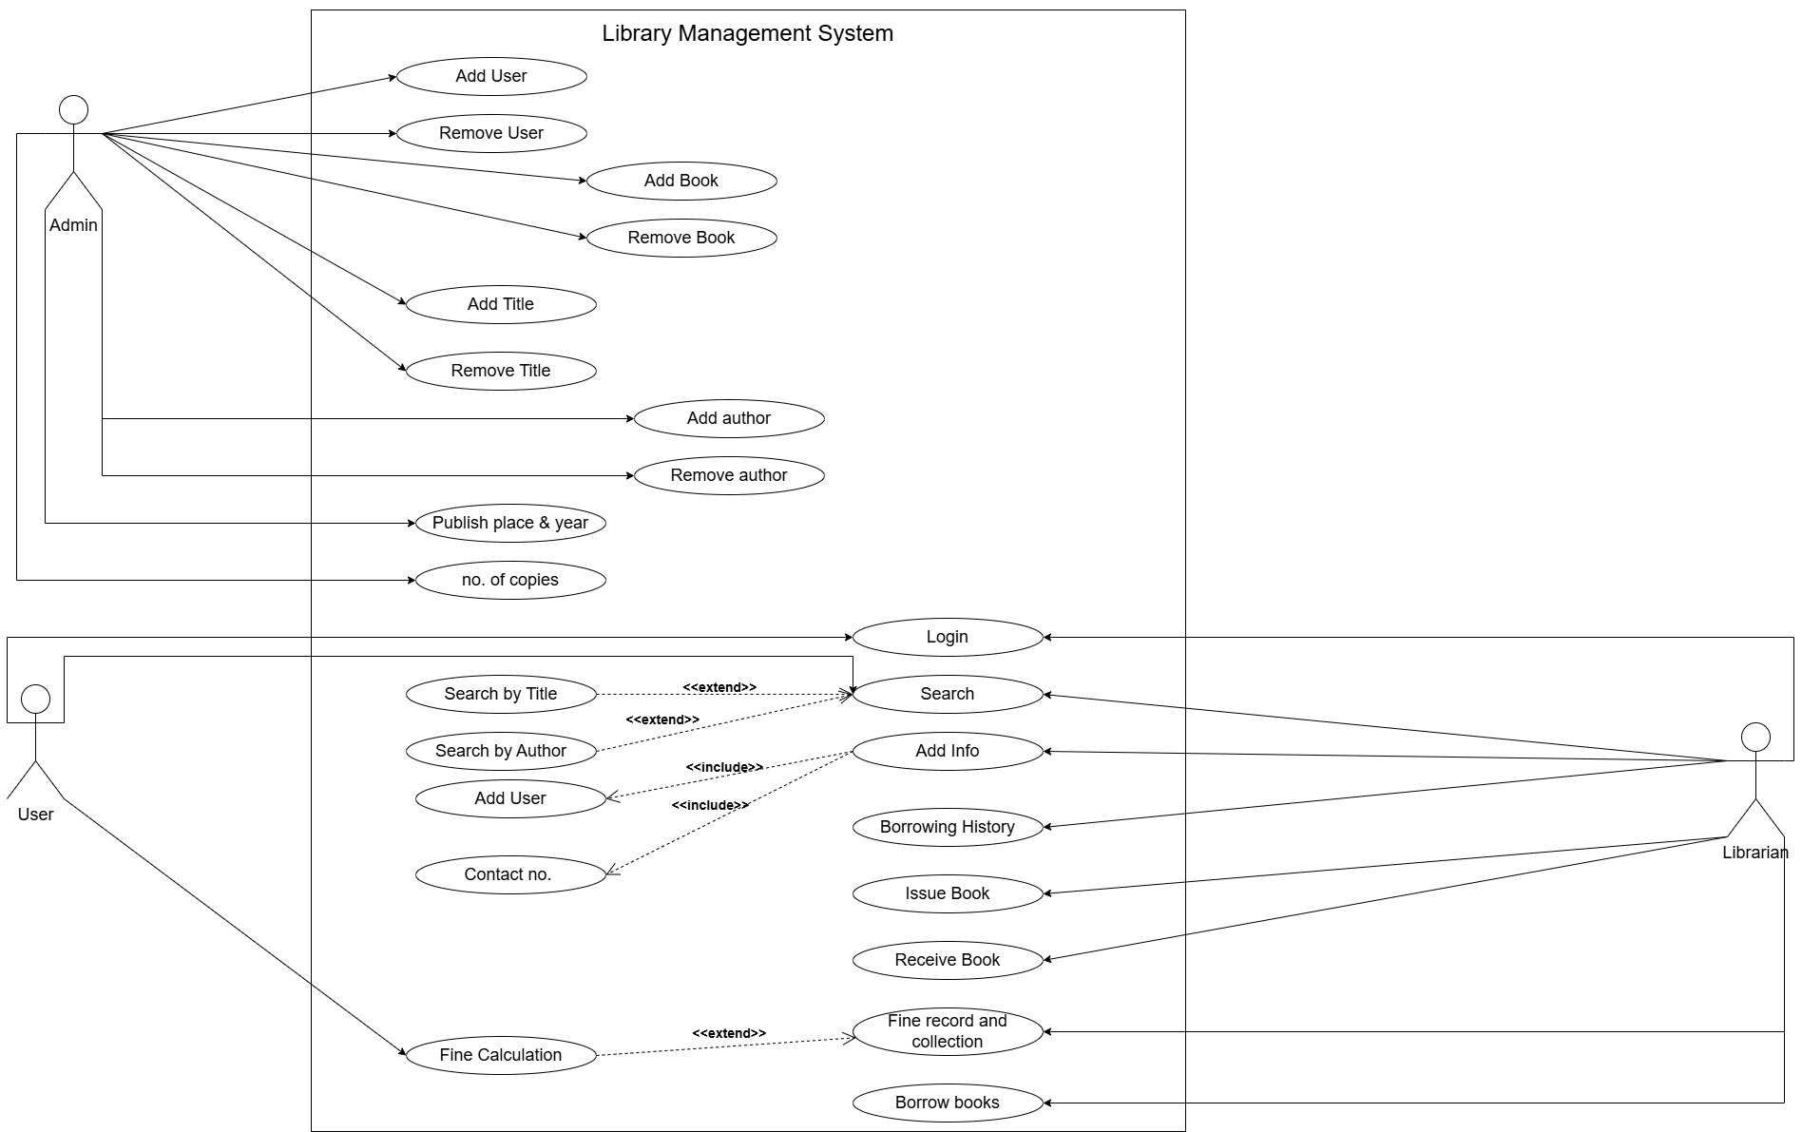

Q3. Create a class diagram for the library information system.

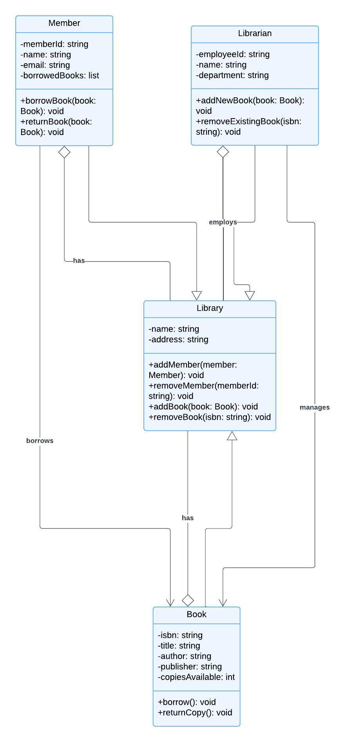

Q4. Implement a C++/Java program to simulate a part of the library information system

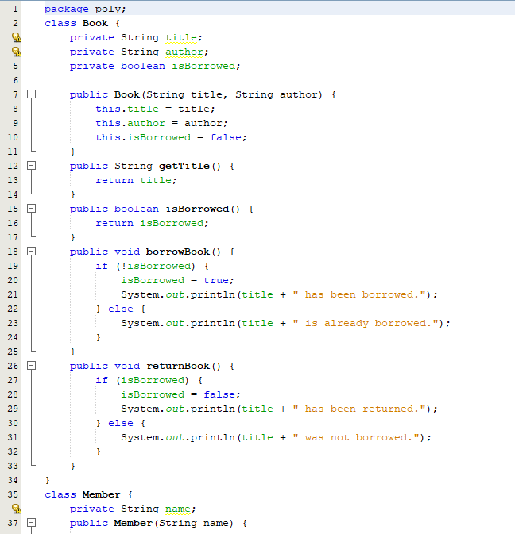

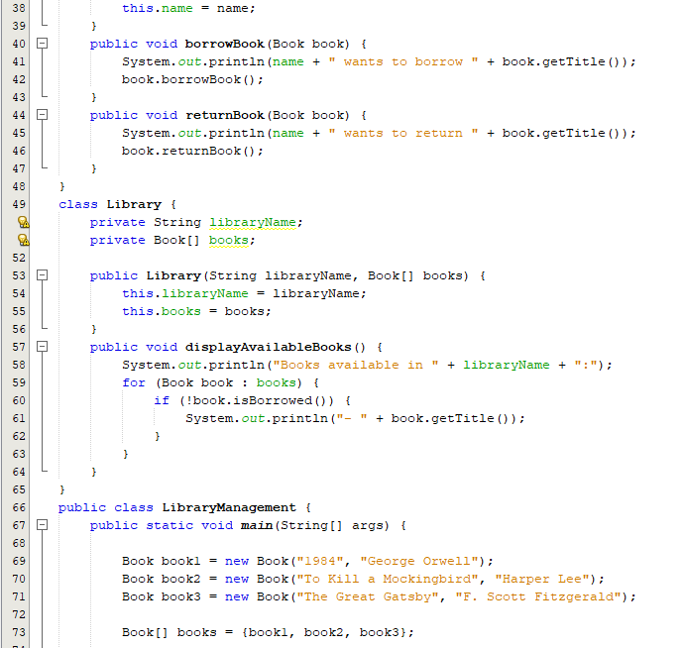

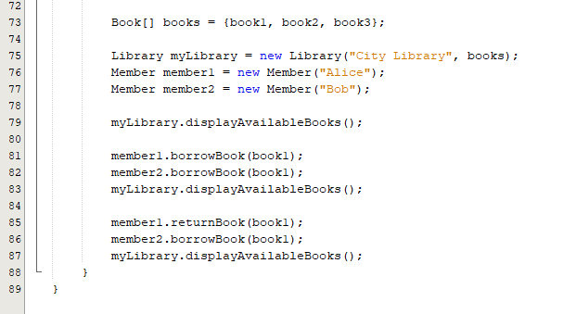

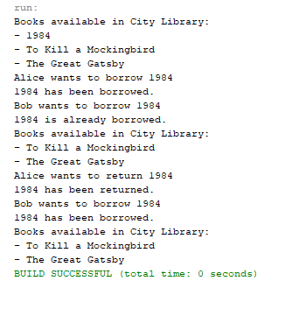

Q5. Write a shell script program to count and report the number of entries present in each sub directory mentioned in the path which is supplied as command line argument.

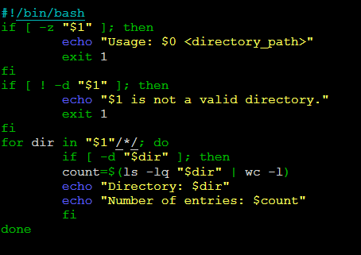

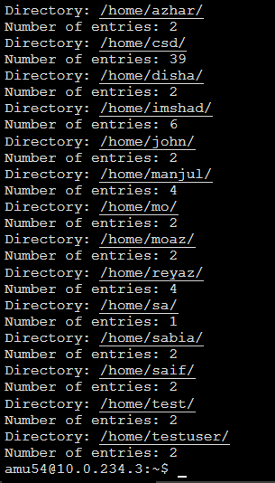

Q6. Write a shell script program to generate all combinations of 1, 2 and 3 using for loops.

